**Capital Asset Pricing Model**

A portfolio is a basket of financial investments that can carry stocks, bonds, cash, cash equivalents, etc. An efficient portfolio is one that is well diversified and fairly compensates you for risk. Diversification is a technique which helps to minimize risk and maximize returns by allocating investments in different areas that would react differently in same circumstance. No matter how much we diversify there’s a part of risk that will always exist. Capital Asset Pricing model (CAPM) is built on the idea of diversification which was developed by William Sharpe. CAPM says the total risk of a financial asset is made up of a diversifiable (unsystematic) and non-diversifiable(systematic) risk, the former is correlated with the general market moves but the latter is not. CAPM helps to calculate risk and return of an investment that an investor should expect.

CAPM describes the relationship between risk and expected return.

The formula is

**ri,t− rf,t = αi + βi(rm,t – rf,t) + ei,t**

Where,

ri,t = observed return for asset i for time t

rf,t = observed return on risk-free rate for time t

rm,t = expected return for the market portfolio for time t

ei,t = error term for time t

The objective is to do regression analysis and find the variability of stocks with market returns. Beta helps to measure the volatility of stock returns with respect to the overall market volatility. Here, the benchmark which is chosen is S&P BSE 500.

**A stock of beta:**

0 indicates no correlation with the benchmark.

1 indicates the expected return on a security is equal to the benchmark.

-1 indicates security has a perfect negative correlation with the benchmark.

More than 1 indicates a stock that’s more volatile than its benchmark.

Less than 1 is less volatile than the benchmark.

**Assigned companies:**

1. Dhanlaxmi Bank Ltd
2. Vidhi Specialty Food Ingredients Ltd
3. Indian Metals & Ferro Alloys Ltd.
4. Gujarat Pipavav Port Ltd
5. Century Plyboards India Ltd
6. Tanla Solutions Ltd

**Process of data analysis**

**(I)Data Preparation:**

1. Get the data :

* The data is taken from Yahoo! Finance, it has monthly stock price data for each of the six assigned companies and S&P BSE 500 for the period of 30 months from April 1, 2018 to September 30, 2020
* The data for monthly yields on Government of India 10-Year Bonds for the period of 30 months from April 1, 2018 to September 30, 2020 is taken from Investing.com.

2. Key variables :

* Log return for a time period is the sum of the log returns of partitions of the time period.
* The S&P BSE 500 data is used as a proxy for the market returns
* Monthly yields on GOI bonds is used as a proxy for risk free rate of return
* Excess returns are the return earned by a stock (or portfolio of stocks) and the risk free rate.
* Equity risk premium refers to an excess return that investing in the stock market provides over a risk-free rate.

3. Import the required libraries

4. Load the data into a pandas DataFrame

5. Preprocess the data

* Extract only the columns that is required for the analysis.
* Detect and treat the null values
* Calculate log returns, equity risk premium and excess returns.
* Log returns : Rt = ln(Pt / Pt-1 )
* Equity risk premium = Expected return of the market - Risk free rate of return
* Excess returns = Return on Asset - Risk free rate of return

**(II)Data Analysis:**

* Summarize the data
* Scatterplot
* Regression summary
* Characteristic line

**Results of data analysis**

**Descriptive statistics of returns of the assigned companies and that of the market index:**

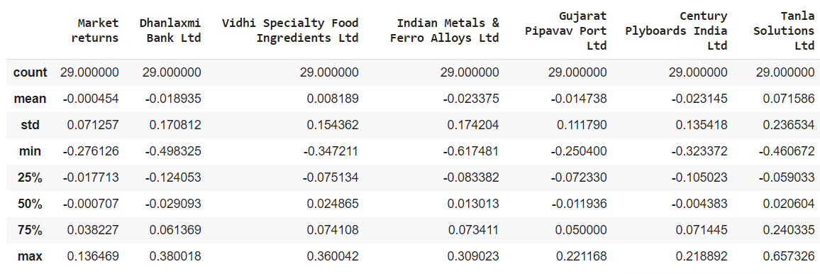

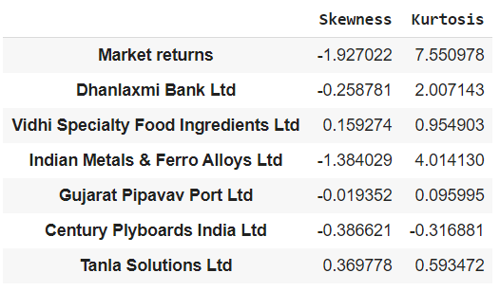

**Plots and summaries :**

1. **Dhanlaxmi Bank Ltd**

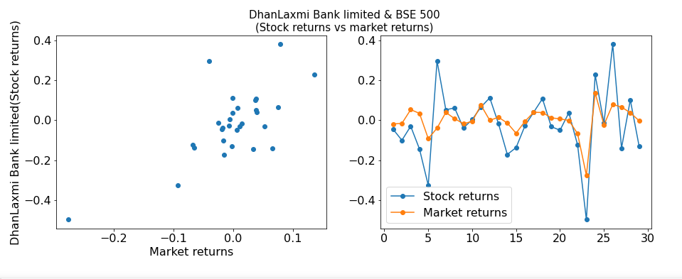 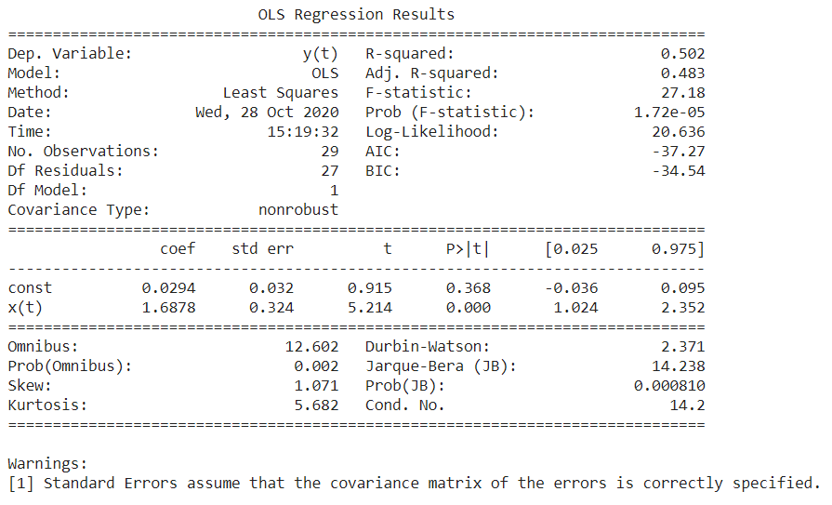

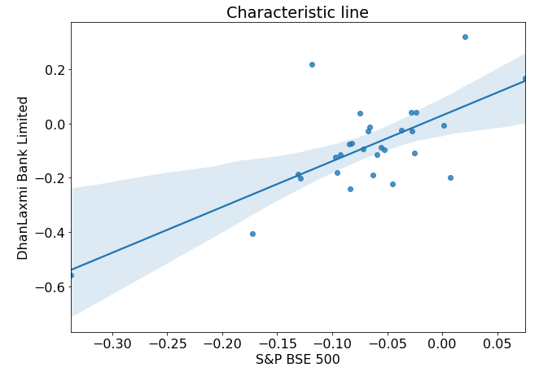 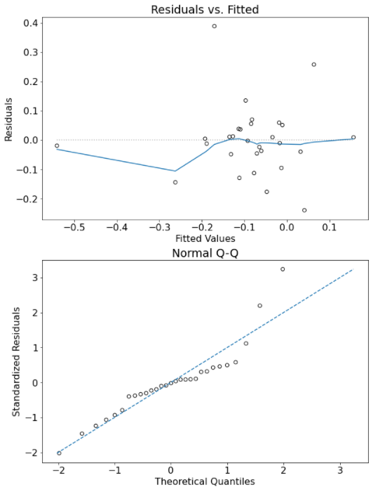

1. **Vidhi Specialty Food Ingredients Ltd**

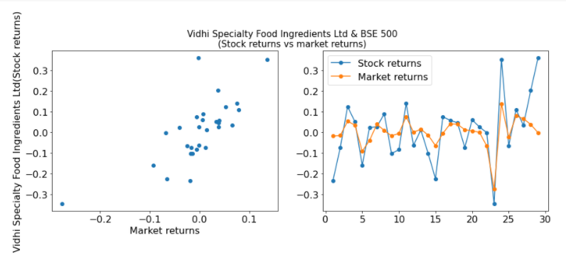 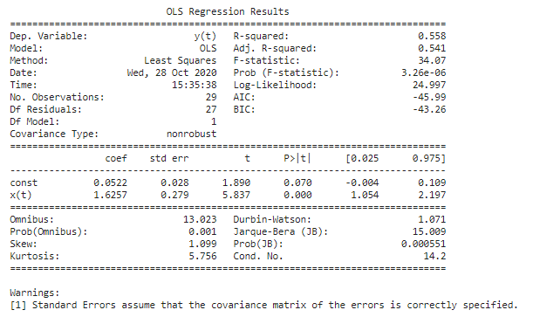 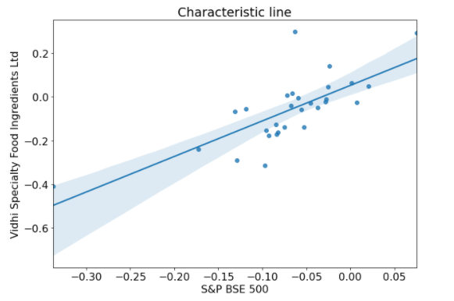 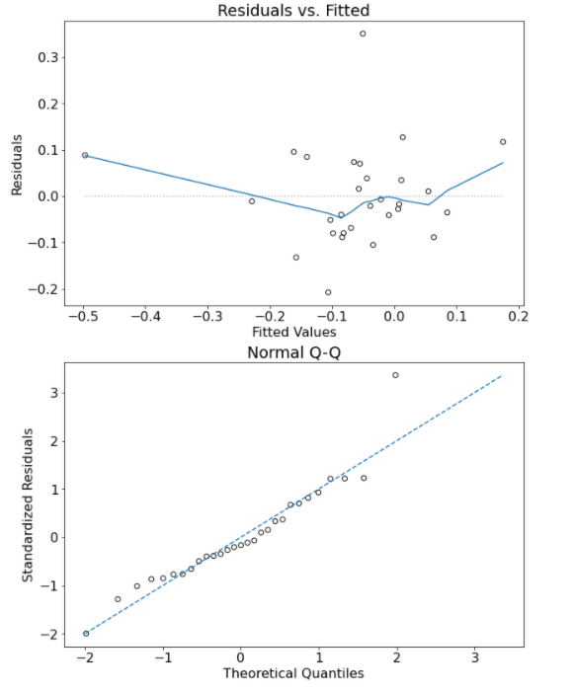

1. **Indian Metals & Ferro Alloys Ltd.**

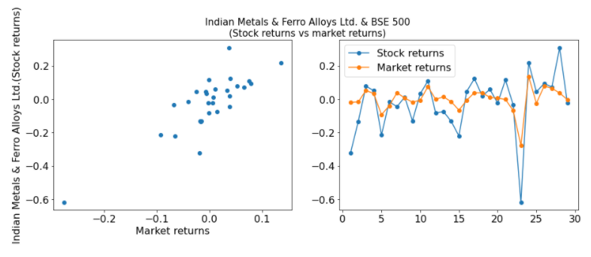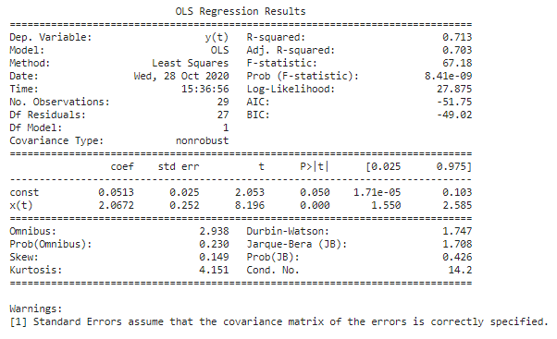 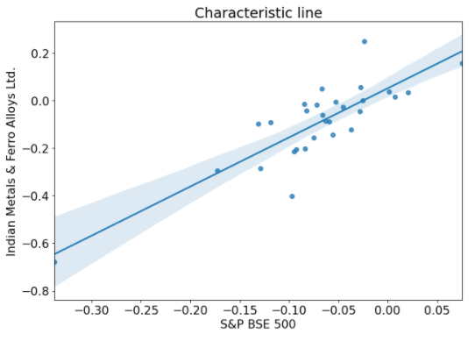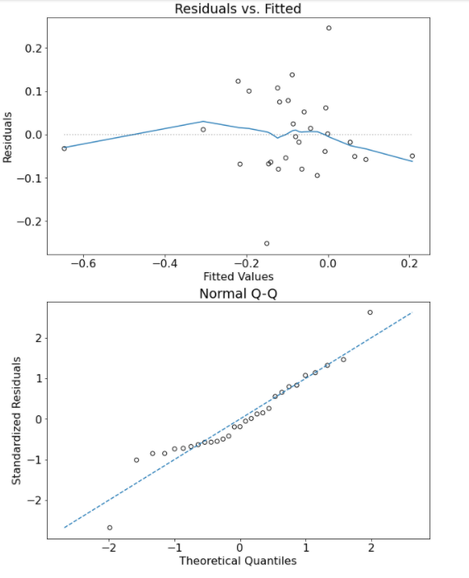

1. **Gujarat Pipavav Port Ltd**

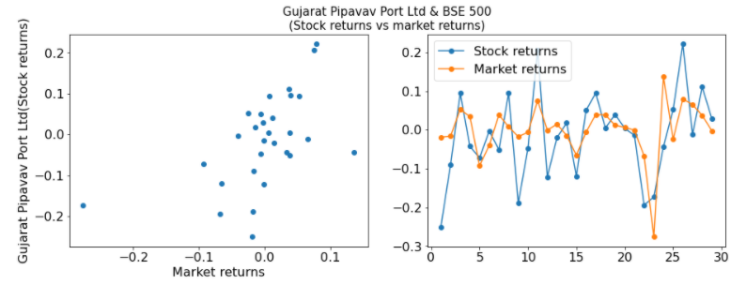 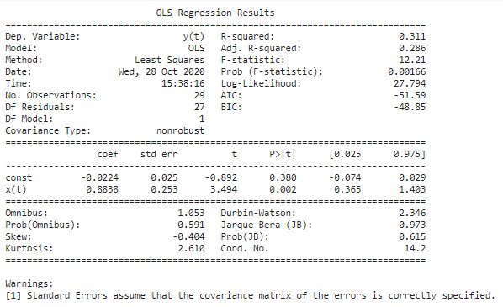 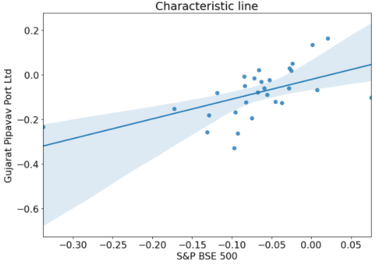 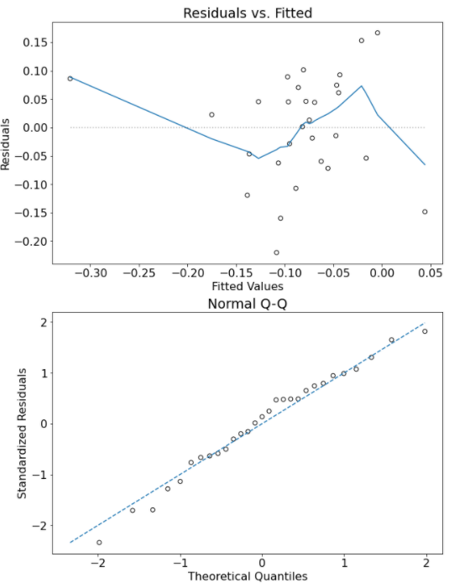

1. **Century Plyboards India Ltd**

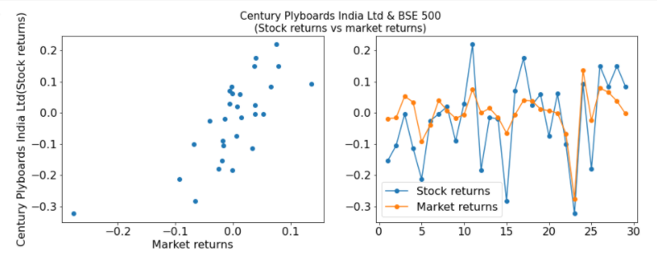 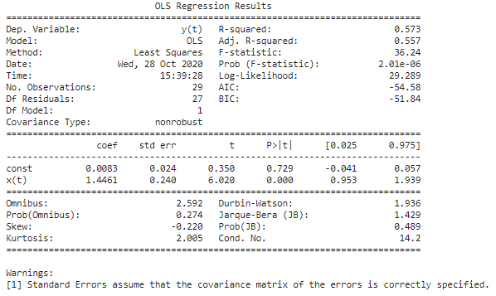 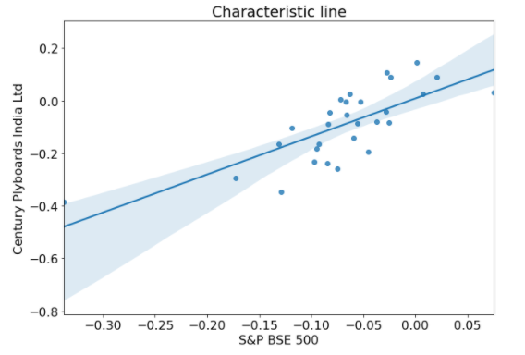 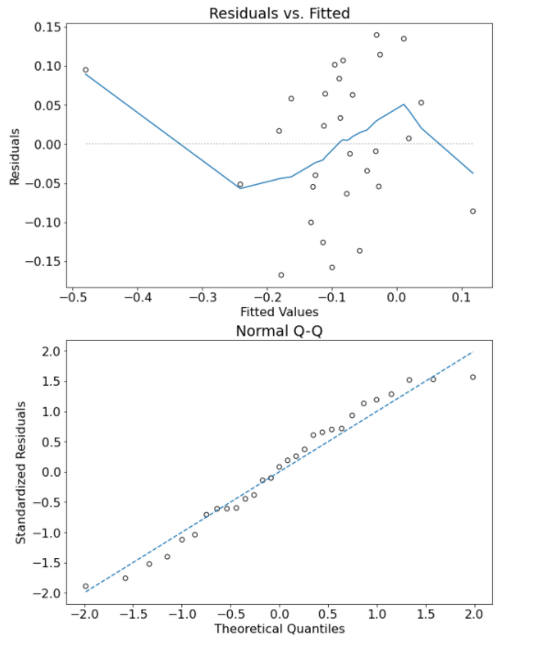

1. **Tanla Solutions Ltd**

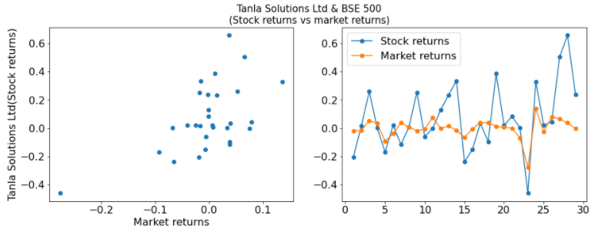 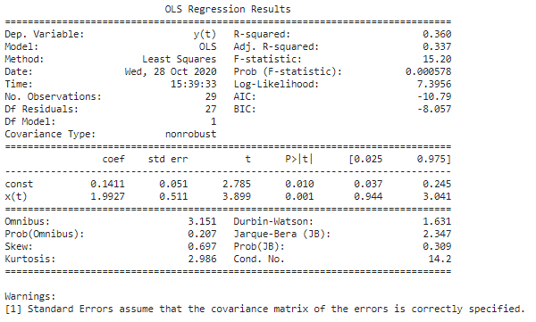 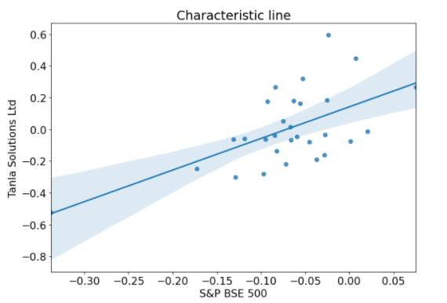 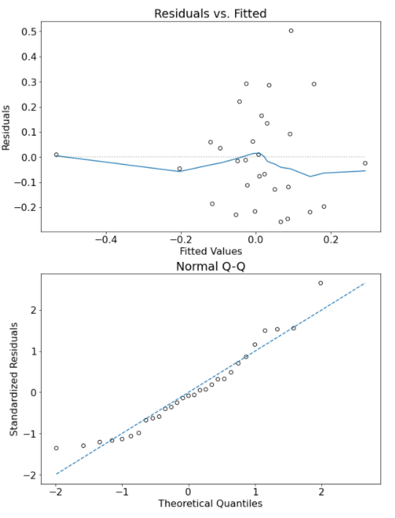

**Conclusion:**

The stock returns of all the assigned companies are positively correlated with the market returns, though, the relation is not very strong.

Beta indicates how volatile a stock's price is in comparison to the overall stock market.

Monthly data of the assigned companies, GOI bond and S&P BSE 500 index for the period of 30 months from April 1, 2018 to September 30, 2020 is used to get the beta values.

|  |  |  |
| --- | --- | --- |
| Company | Beta | Volatility  (w.r.t. to the overall market) |
| Dhanlaxmi Bank Ltd | 1.6878 | More volatile |
| Vidhi Specialty Food Ingredients Ltd | 1.6257 | More volatile |
| Indian Metals & Ferro Alloys Ltd | 2.0672 | More volatile |
| Gujarat Pipavav Port Ltd | 0.8838 | Less volatile |
| Century Plyboards India Ltd | 1.4461 | More volatile |
| Tanla Solutions Ltd | 1.9927 | More volatile |

The stock returns of all the assigned companies follow the general market trend.